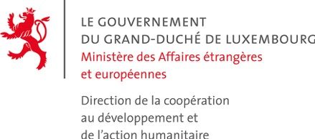 | Business Partnership Facility (BPF) | 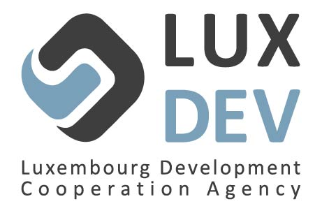

BPF 2018 FACILITY
Application form

This application form must be submitted in an electronic format to: bpf@luxdev.lu

Candidates may attach any document they consider appropriate.
Throughout this application form, the term “lead partner” refers to the Luxembourgish or European private company representing the candidate and which ensures the coordination task. Public or private partners from the developing countries where the project is envisaged to take place are called “local partners”. Other potential partners, private or public, Luxembourgish or European, are called “associated partners”. Finally, “candidate” refers collectively to the lead partner, the local and all possible associated partners.

- CANDIDATE IDENTITY
  - Identity of the lead partner
Company name
Trade register number
VAT number
Share capital
Creation date
Staff (in full-time equivalent)
Website
Head Office Address
[No, street, postcode, town]
Business sector | TIC ☐ | Biohealth ☐ | Fintech ☐ | Eco-innovation ☐  Circular economy ☐ | Logistics ☐
Turnover (EUR) of the company | 2016 |  |  | 2017
Type of business operations

  - Contact person
Name
Position
Phone number
Email address
  - Identity of the associated partners (if applicable)
Associated partner 1
Company name and contact details
Business sector
Creation date
Turnover (EUR) | 2016: | 2017:
Associated partner 2
Company name and contact details
Business sector
Creation date
Turnover (EUR) | 2016: | 2017:

- PROJECT OUTLINE (Concept note)
  - Target countries
[Please name the country(ies) where the candidate plans to implement the project. Preference will be given to the Luxembourg Cooperation partner countries: Burkina Faso, Cabo Verde, El Salvador, Kosovo, Laos, Mali, Mongolia, Myanmar, Nicaragua, Niger, Senegal and Vietnam and Ethiopia]
  - Project description (maximum 2 pages)

[Describe the project in maximum 2 pages. No specific format is required. The candidate may describe the market targeted by the project, the planned investments and the expected results, the target audience, the activities to be undertaken and the project’s maturity stage]

  - Expected impact(s) of the project
☐ Job creation
☐ Technology and/or knowledge transfer
☐ Impact on economic development of the target country(ies)
☐ Environmental impact
☐ Social impact
☐ Replication / multiplication

  - Local partner(s) envisaged in the target country(ies)
☐ Private sector
☐ Civil society
☐ Public sector
☐ Research Institute
☐ Other
[Please specify the identity of the local partner if already identified and briefly describe the nature of its activities]
  - Budget
Total project budget (EUR)
Amount requested through co-financing – maximum 200.000 EUR and maximum 50% of the budget
[As a reminder, the candidate has to cofinance the project from its own funds and not from a grant obtained from another public actor. Pursuant to the regulations on the “de minimis” aid, particular attention must be paid to the compliance with the public aid ceiling which may not exceed 200.000 EUR over the last two fiscal years and the current fiscal year all aids combined. In this context, the candidate is required to complete the table below (whether the beneficiary of the received aid is the leader partner or one of the associated partner) and to sign the statement of good standing. For more details on “de minimis” aids, please refer to the “guide pratique”, chapter 1.4].
Recipient company | Denomination of the aid | Amount received | Source of the aid | Date of granting

- STATEMENT OF GOOD STANDING

Object: Call for projects - BPF Facility 2018

I (we) the undersigned ………………………………………………………………………………........... (names), in my (our)capacity of ……...……………………………………………………….……………………(positions), for the company …...…………………………………………………………………………… (name of the entity), established in ………...………………………………………………………….……............. (place of registration),
Certify that the entity I (we) represent:
- is not bankrupt, is not being wound up, has not ceased operations, is not having its affairs administered by the courts, has not entered into an arrangement with creditors and is not in any analogous situation arising from a similar procedure provided for in national legislation or regulations;
- is not the subject of proceedings for a declaration of bankruptcy, of administration by the court, of winding up, of an arrangement with creditors or of any other proceedings of that nature in national legislation and regulations;
- has not been convicted of an offence concerning professional conduct, including environmental crimes or acts against environmental regulations and legislations (regardless of the country), by a judgment, which has the force of res judicata;
- has fulfilled its obligations relating to the payment of social security contributions in accordance with the legal provisions of the country in which it is established;
- has fulfilled its obligations relating to the payment of taxes in accordance with the legal provisions of the country in which it is established;
- has not been guilty of serious misrepresentation in supplying the information required for its participation in procedures pertaining to call for tender and call for proposals;
- has not been in breach of its contractual obligations in the performance of contracts with the same Contracting Authority and/or other contracts financed by the Donor in the country of the Contracting Authority and/or any other country;
- is in compliance with the regulations on the “de minimis” aid;
- and declares to have read and to accept all the conditions of the BPF, especially the co-financing for a minimum of 50 % through its own funds.

I am (we are) aware that Lux-Development is entitled to request proof that the company I (we) represent is not in any of the situations referred to above.
Done in ………………..……. on …………………… 2018

For the Candidate

Signature(s)

- JOINT COMMITMENT

Object: Call for projects - BPF Facility 2018

The entities listed below jointly and severally commit themselves as candidate for the above-mentioned call for projects. In case their application is retained, those entities declare to intend to submit a collective detailed proposal that will jointly and severally commit them.

Entity’s name and address: | Signature:

The lead partner is:
………………………………………………………………………..

Done in ………………..……. on …………………… 2018

Signature of the lead partner

Signature of the other partners

Please briefly describe the type of business operations. Specify the geographical areas of implementation, especially if one or more developing countries are concerned.

